### MAJOR PROJECT 1

**END SEM REPORT**

### ON SWASTHAHINDUSTANI (Android App)

**Submitted By**

|  |  |  |
| --- | --- | --- |
| DIVYANSHU GUPTA | AMRIT KUMAR | KANISH RAJPALI |
| R100217023 | R100217007 | R100217000 |

Under the guidance of Mr. Ankur Misra



### OPEN SOURCE AND OPEN STANDARDS

**Department Of Cybernetics School of Computer Science**

**UNIVERSITY OF PETROLEUM AND ENERGY STUDIES**

**Dehradun-248007**

**Aug-Dec, 2020**

**Abstract**

This project aims to build an online hospital android app for patients, finance company and hospital with some new features. It is app which is totally different from other hospital app as it allows patients to book appointment, pay bills and even order medicines. In this app patient will able to pay the bill using EMI’S. Patient can take video consultation from doctors whenever they want. Patients can even book blood test appointments.

In this project we are creating app for client/patient where they can perform various operations such as: - [1]

1. Book Appointments
2. Pay Bills using EMI’s
3. Order Medicines
4. Video Consultation
5. Book Blood Test

Keywords: Patient, Hospital, EMI, Medicines, Pay, Bill, Appointment, Consultation.

### INTRODUCTION

Online Smart-Health App for patients. In this app patient can book appointments and pay bills using EMI. This app will allow patient to search best hospital in town for a specific treatment. Patient can have any EMI plan for paying their bills.

It is app which is totally different from other hospital app as it allows patients to book appointment, pay bills and even order medicines. In this app patient will able to pay the bill using EMI’S. Patient can take video consultation from doctors whenever they want. Patients can even book blood test appointments.

In this project we are creating app for client/patient where they can perform various operations such as: -

* + Book Appointments
  + Pay Bills using EMI’s
  + Order Medicines
  + Video Consultation
  + Book Blood Test

### MODULE DESCRIPTION

# Splash Screens or App tour

Splash 1

Splash 2

Splash 3

Sign In

Sign In

## Login: Password:

Login

3

# Register

Name : Email ID:

Phone Number: DOB:

Signup

Govt related Scheme Apply

1. Name, phone and DOB Autofill
2. Pan Card
3. Adhaar card or Ration card or BPL card
4. Photo
5. Monthly income

Submit

All Govt Listing Scheme

Health EMI card Apply

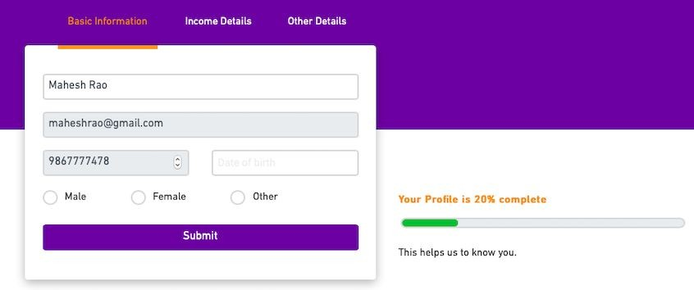

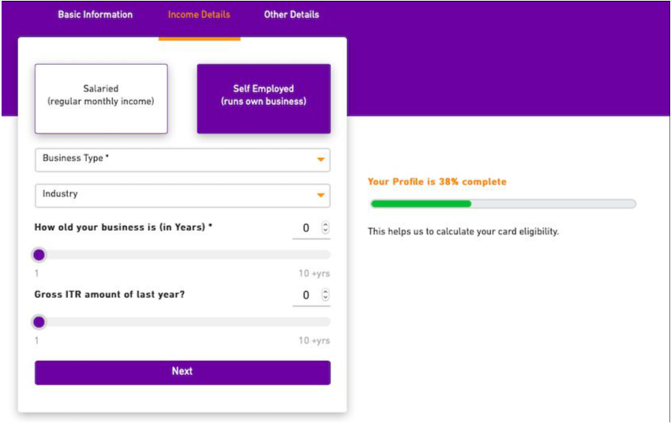



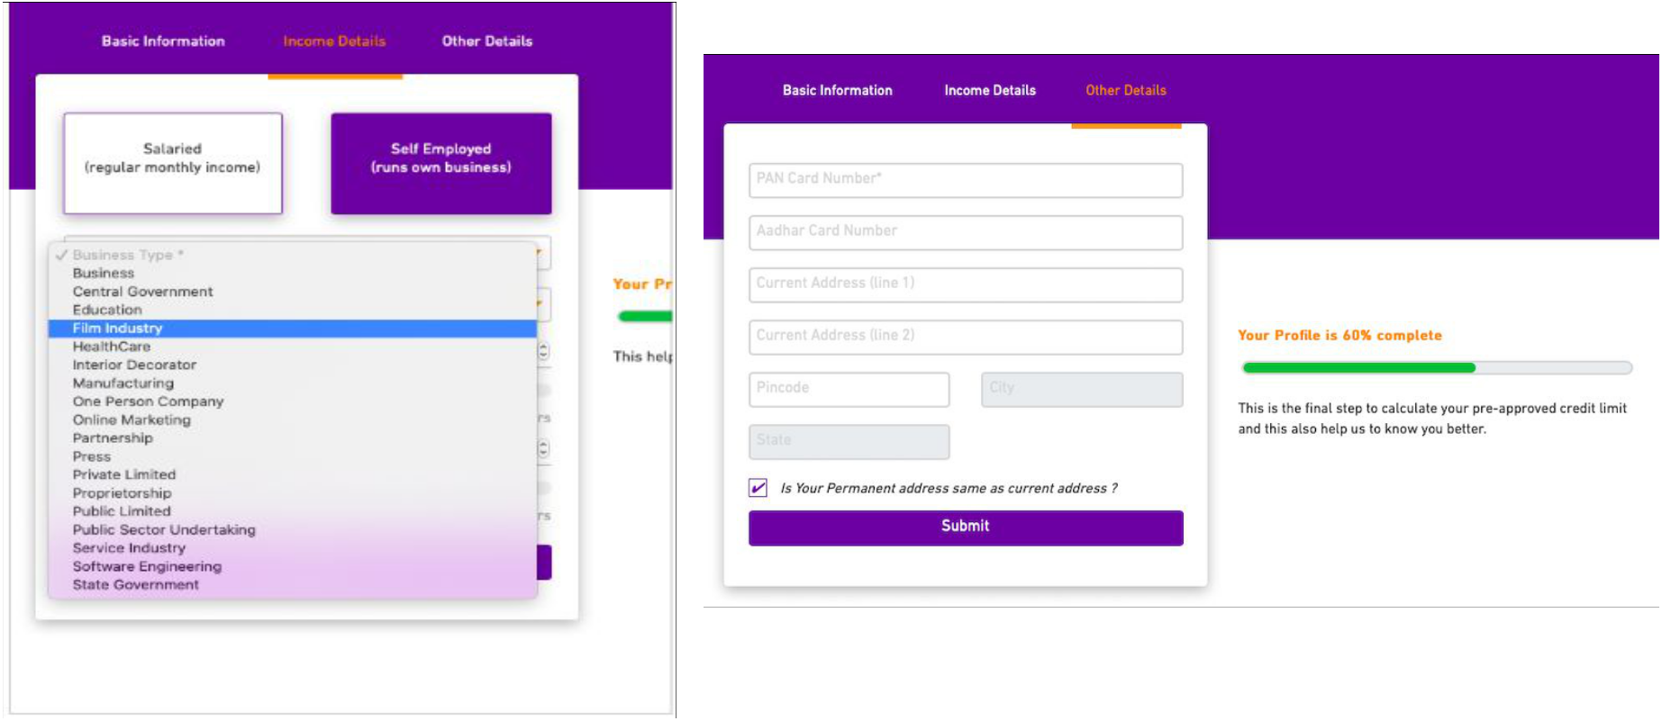

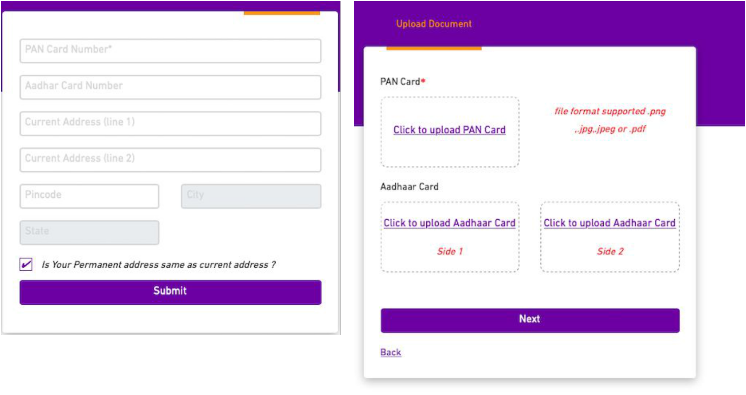

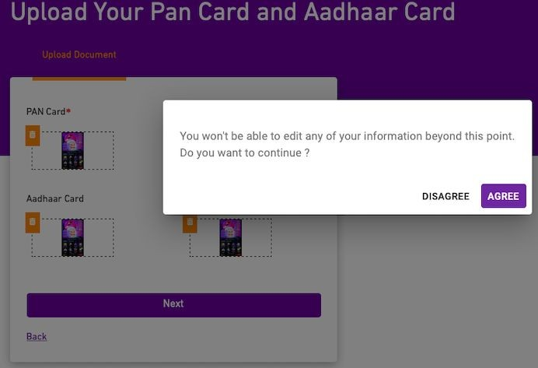

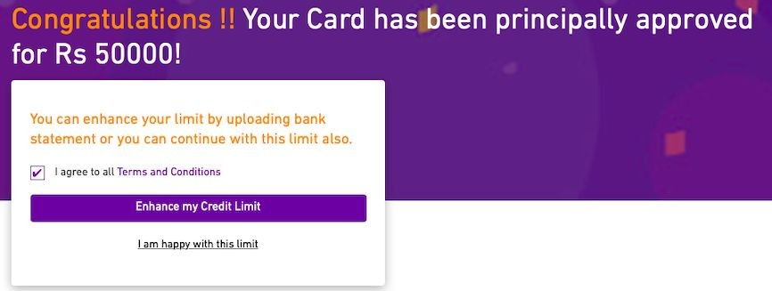

# Menu - My EMI card or credit line

Approved Amount - 20000 Used amount - 5000 Available balance - 15000 View report

EMI Card

Unique Card Number - 16 Digit

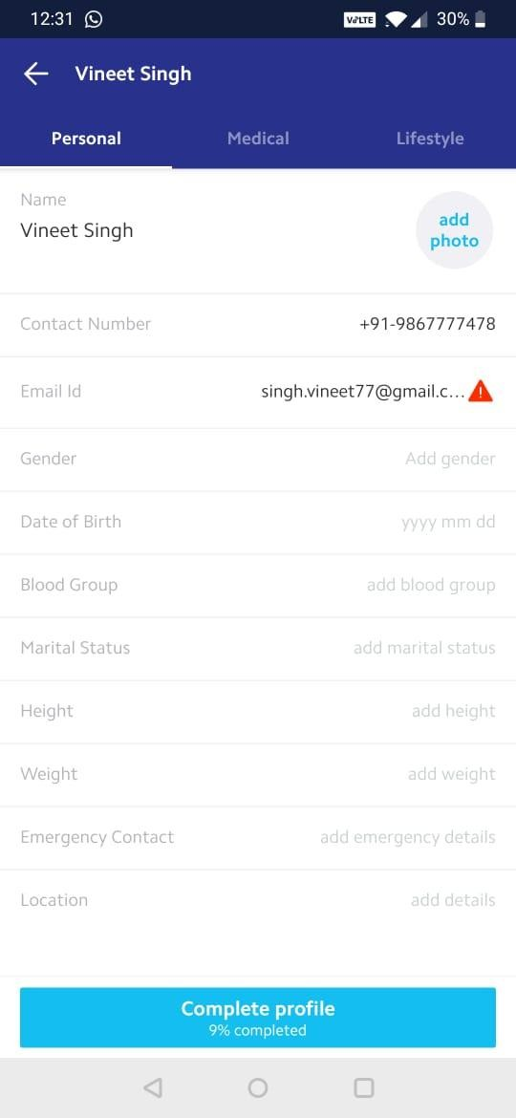

Menu - Profile

## Profile (view and edit profile 9 % completed)

Dashboard Slider (2 -3 slider with information)

## Govt related scheme and apply button

Apply Pre approved EMI health card

Hospital Packages listing

Body Check up and lab tests

Menu (Profile,My EMI card, My order/booking, rewards,about us, Help & support)

View services list

**Services for you**

Change Location

## Search service

|  |  |  |
| --- | --- | --- |
| **Select Service** | **Hospital** | **Approximate Cost** |
| Service 1 | Hospital 1 | Cost 1 |
| Service 2 | Hospital 1 | Cost 2 |
| Service 3 | Hospital 2 | Cost 3 |
| Service 4 | Hospital 3 | Cost 4 |
|  |  |  |
|  |  |  |

15

Hospital/ Lab Packages details

## Title :

Image : Description:

Hospital / Lab name Amount :

Checkout Page

Service Requests Hospital/lab

Confirmed by Hospital

Book Now

Call me back

## Book Now - Credit line Approve Or Apply Now - Not yet Applied

Schedule the treatment (Booking Page)

Bill Generated (Order details page)

# My Booking

|  |  |
| --- | --- |
| Booking Details | Order |
| 1. Booking Id  Hospital/Lab Name Amount  Tittle Description :  Booking time & Date : Dynamic Status : Pending/Approval | |

My Booking

|  |  |  |
| --- | --- | --- |
| Detail View | | |
| Loan Amount | | |
| Paid Amount | | |
| Remaining Amount | | |
| EMI Amount | | |
| Total No of EMIs | | |
| Down Payment | | |
| EMI Schedule Payment | | |
| No. | Due Date | EMI amount |

1. Bill Id

Hospital/Lab Name Amount

EMI Tenure 12 Description :

Order Details

Invoice

View More

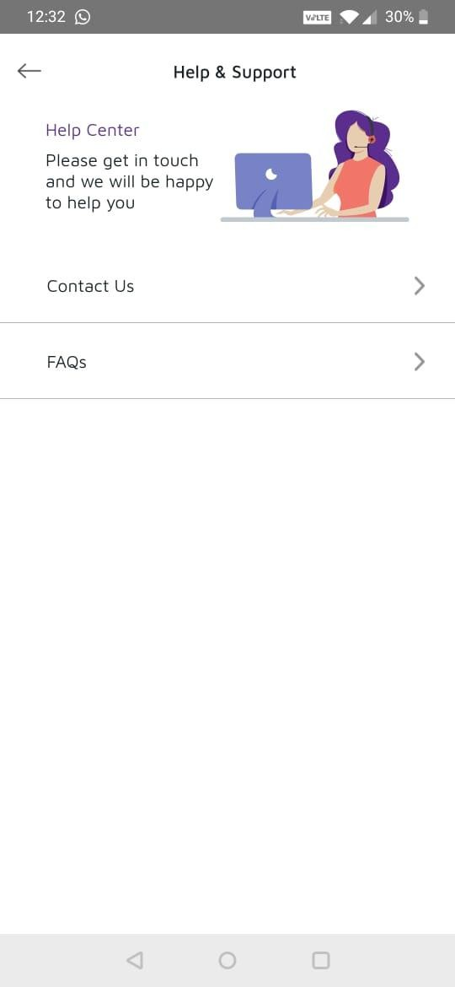Help and Support

1. Use Case Diagram

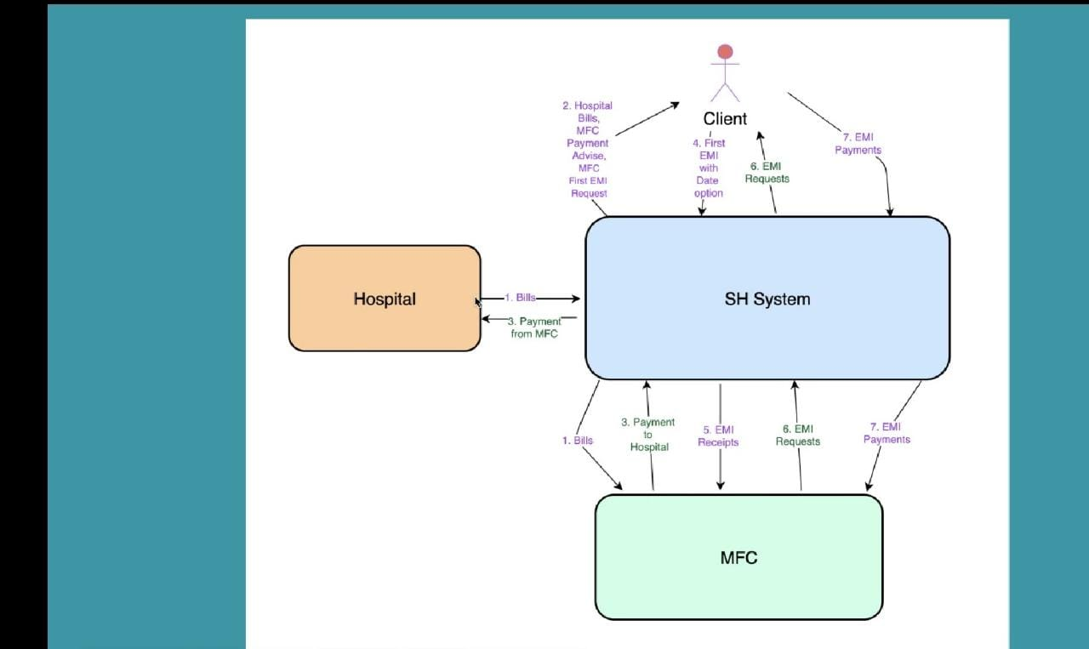

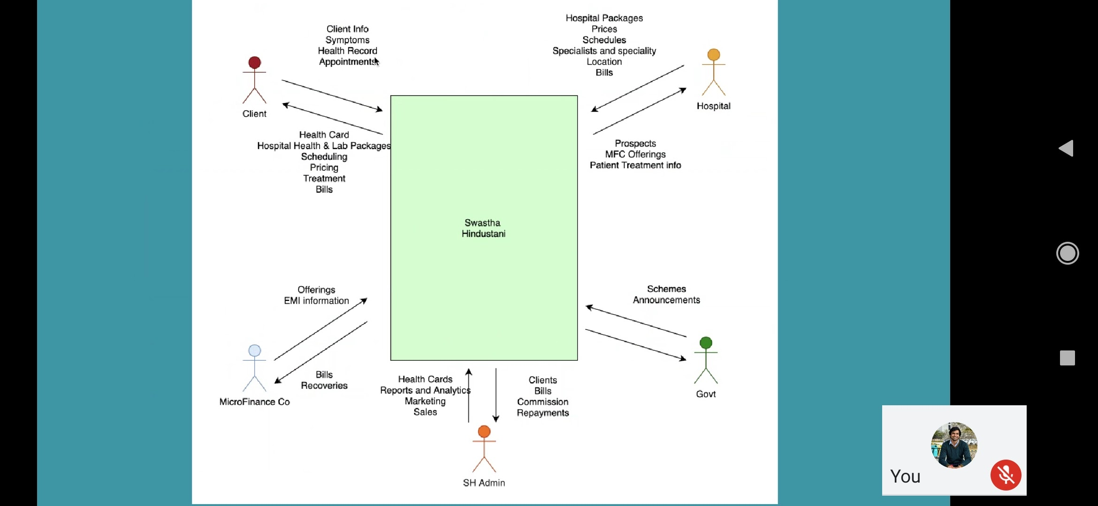

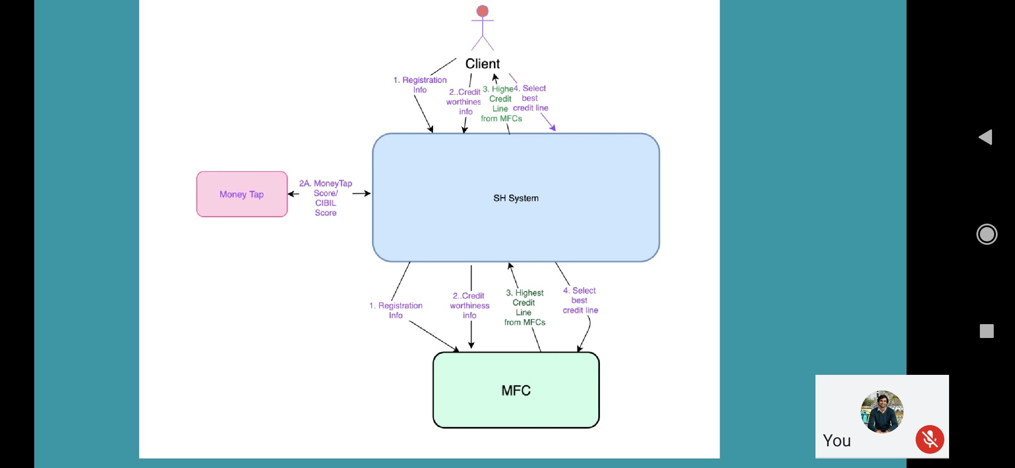

1. **SYSTEM REQUIREMENTS**

**SOFTWARE REQUIREMENTS: -**

• Operating system: Windows 10

• Editor: Visual Studio Code

• Language/Technology: React Native (JavaScript, NodeJs, CSS, Sequelize ORM)

• Emulator: Android Virtual Device (AVD)

• API Testing Tools: Postman

**HARDWARE REQUIREMENTS: -**

• Hard Disk:

• Ram: 4 GB or Above

• Mobile: Android

**Screen Shots**

** **

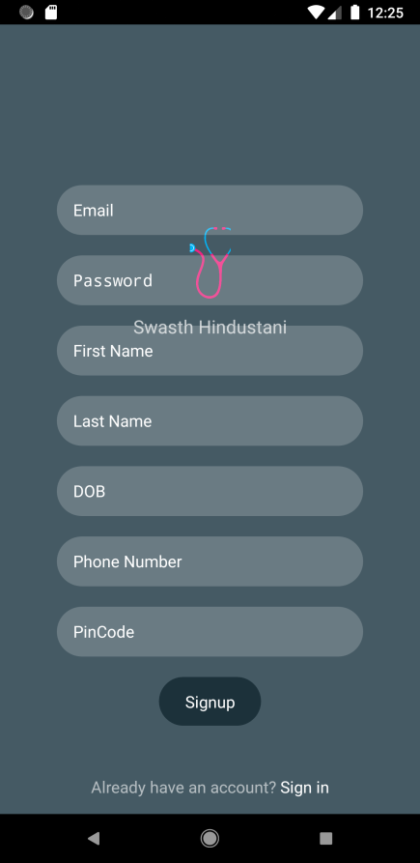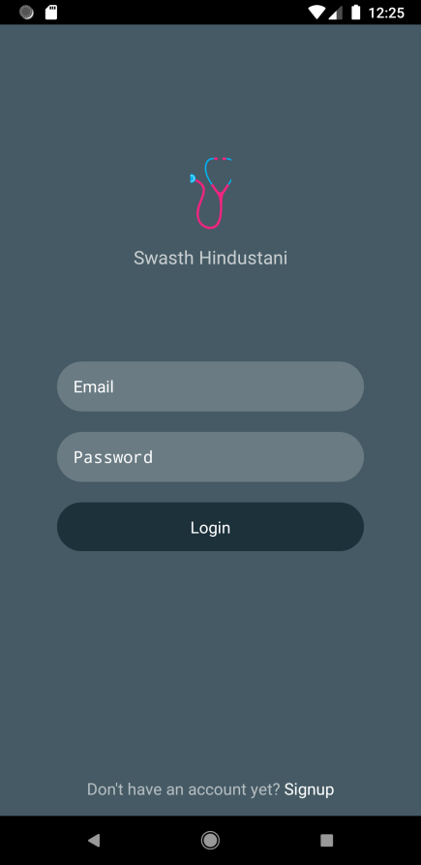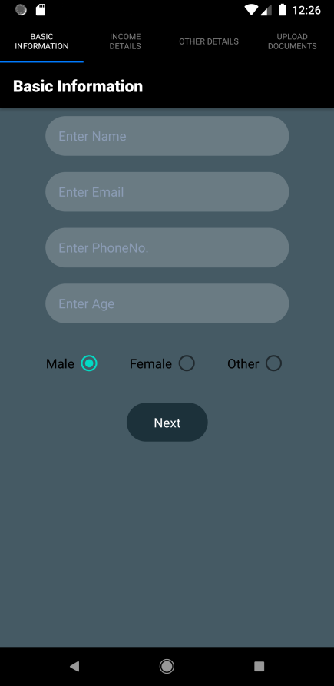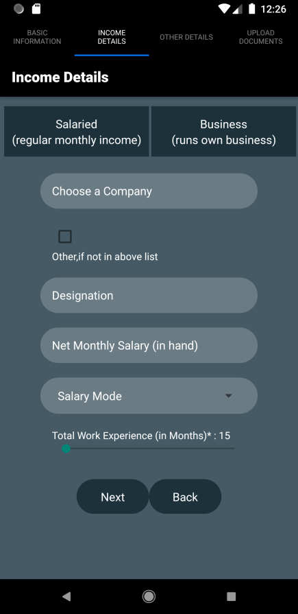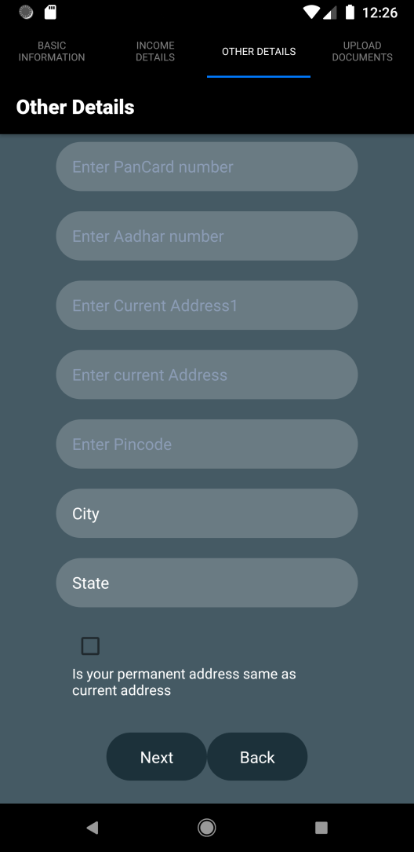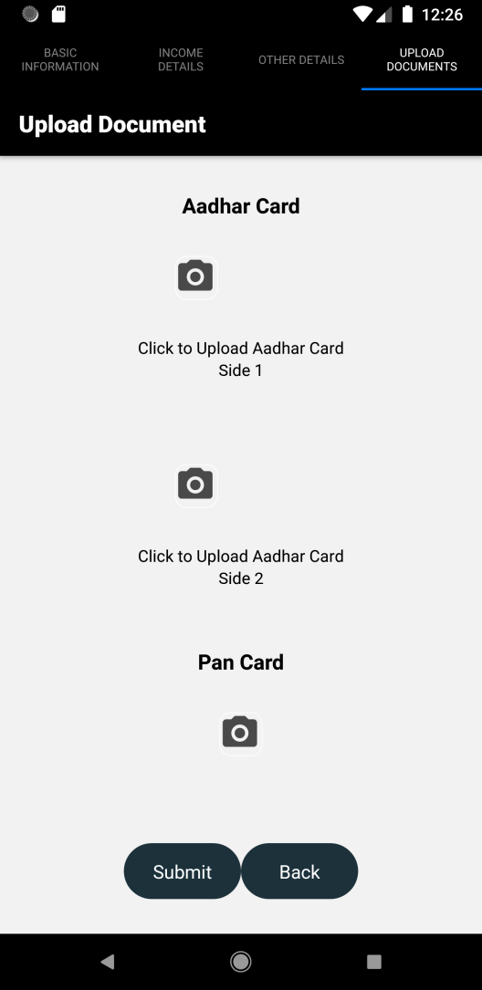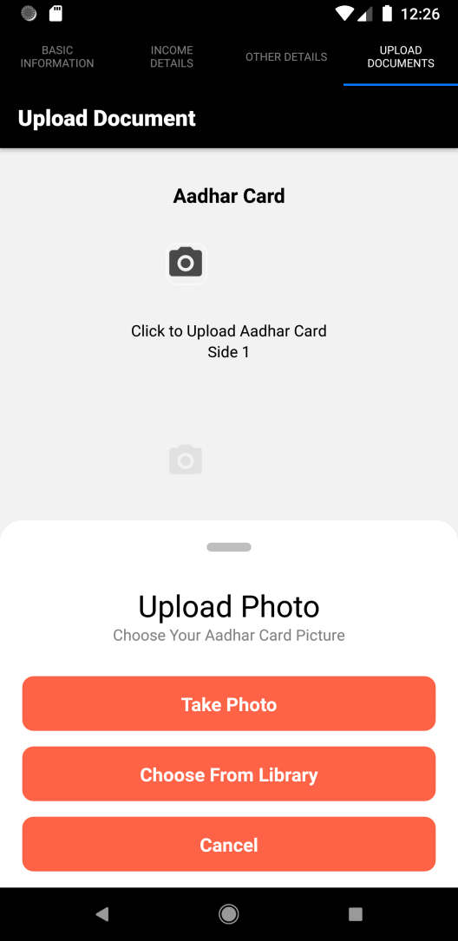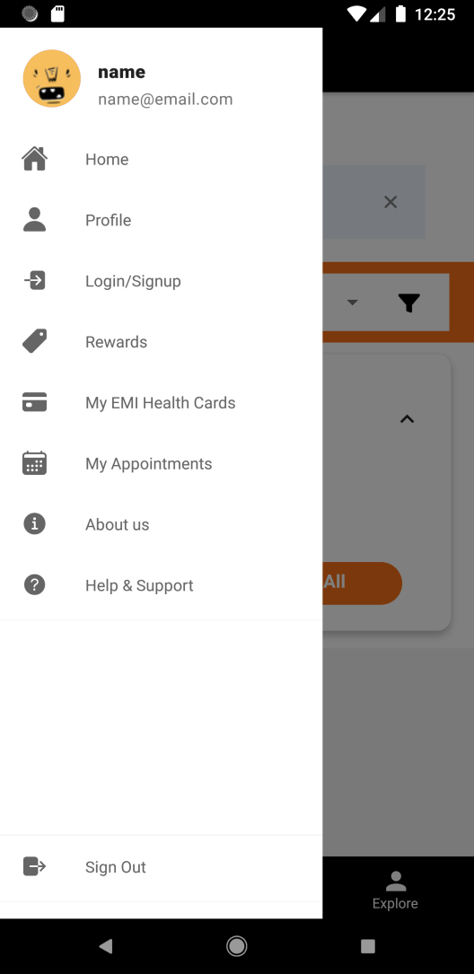

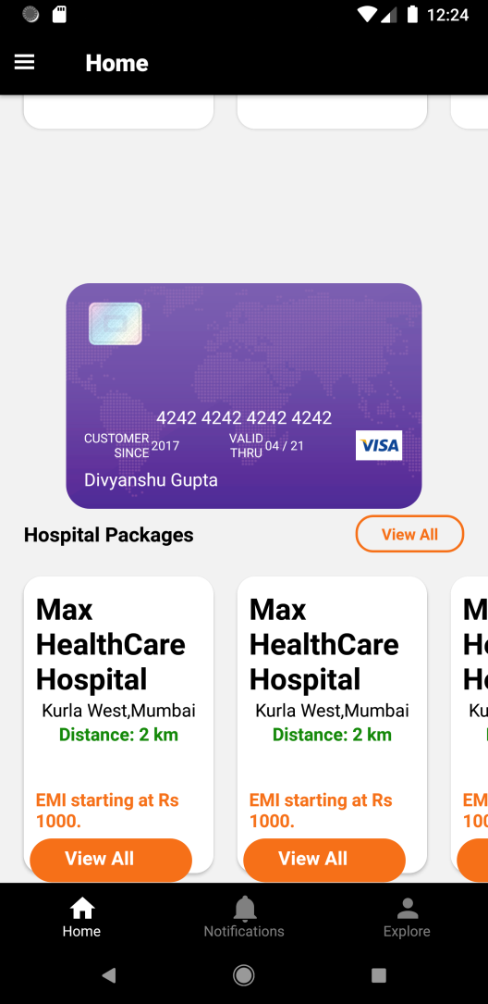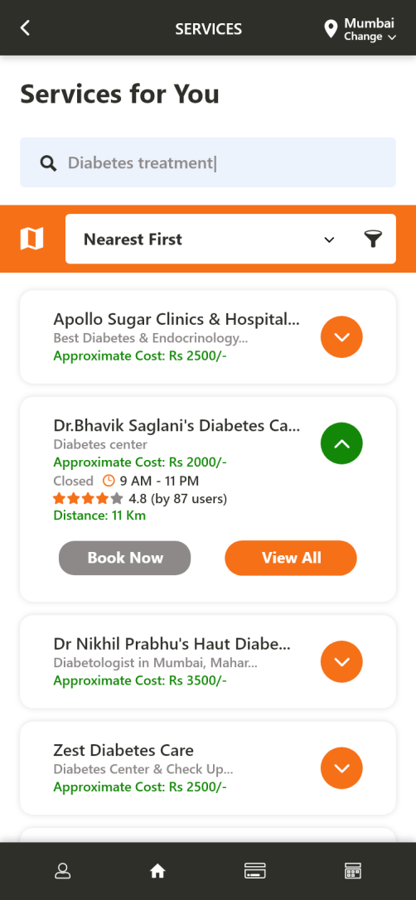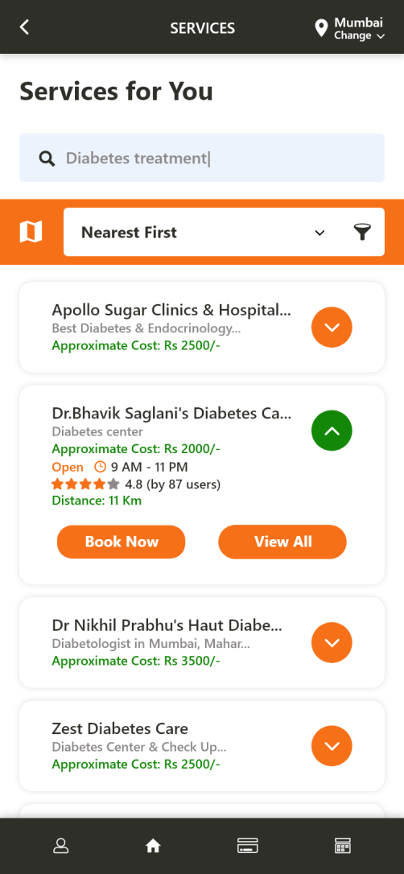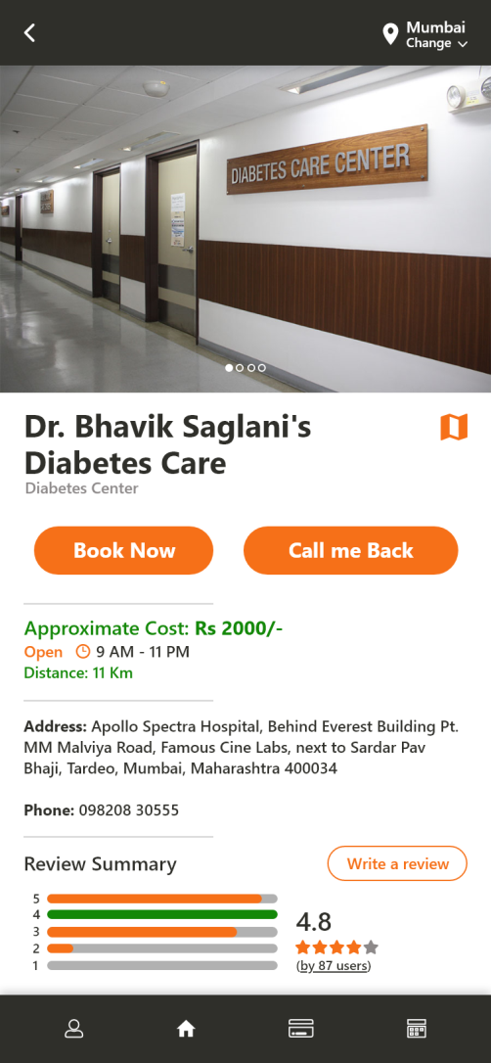

# APPROVED BY

**Mr. Ankur Misra**

**Mentor**